1. cloned from github: 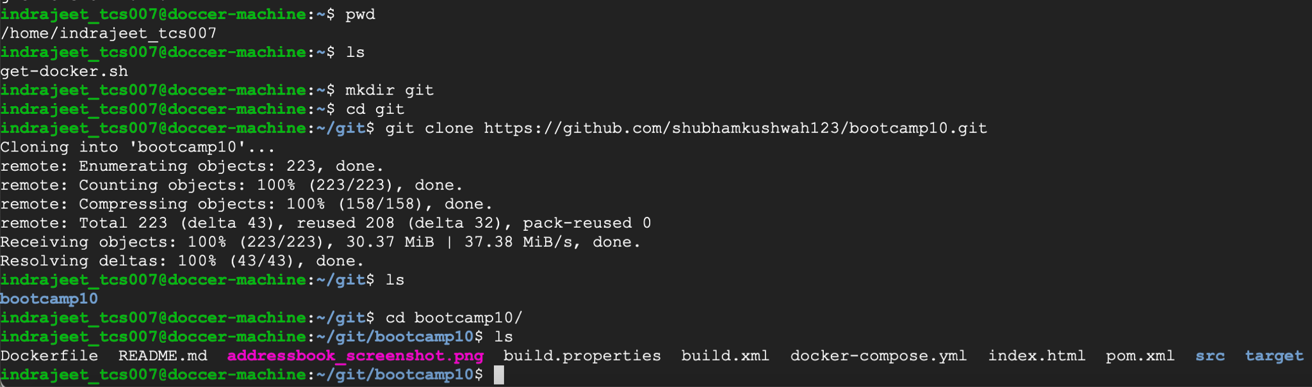
2. created the docker file: 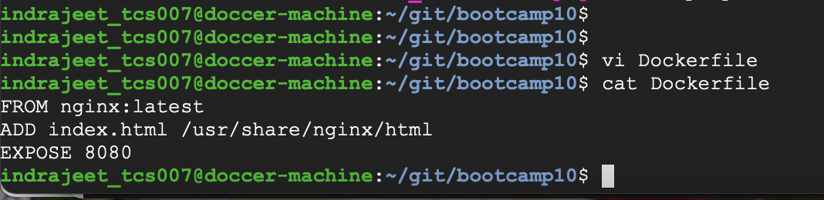
3. built image from the docker file: 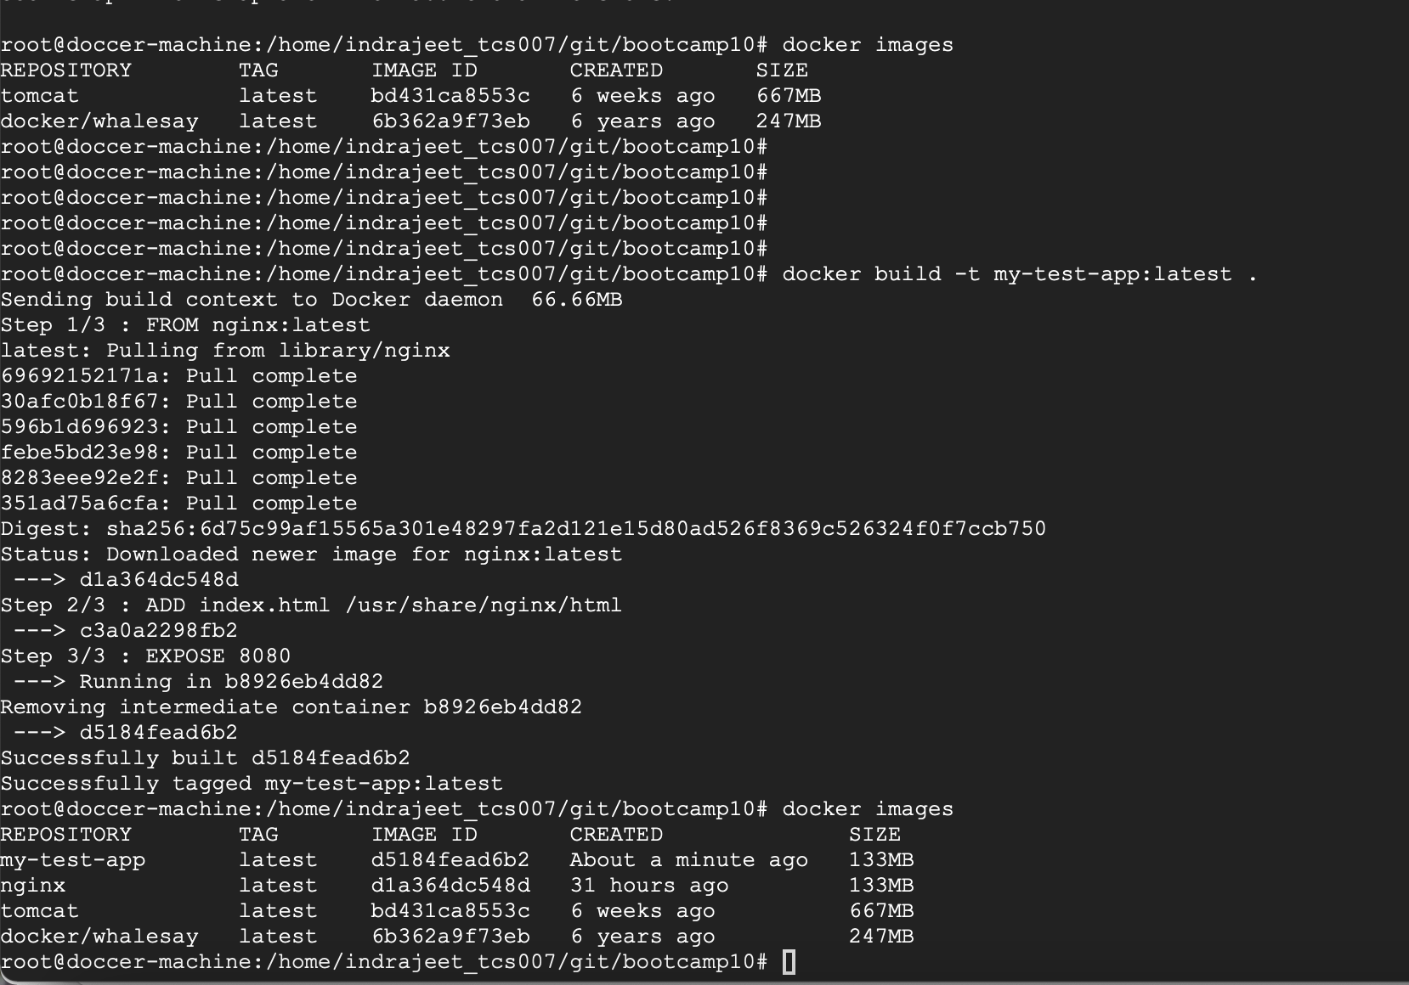
4. pushed the docker image to docker hub after logging in from command prompt: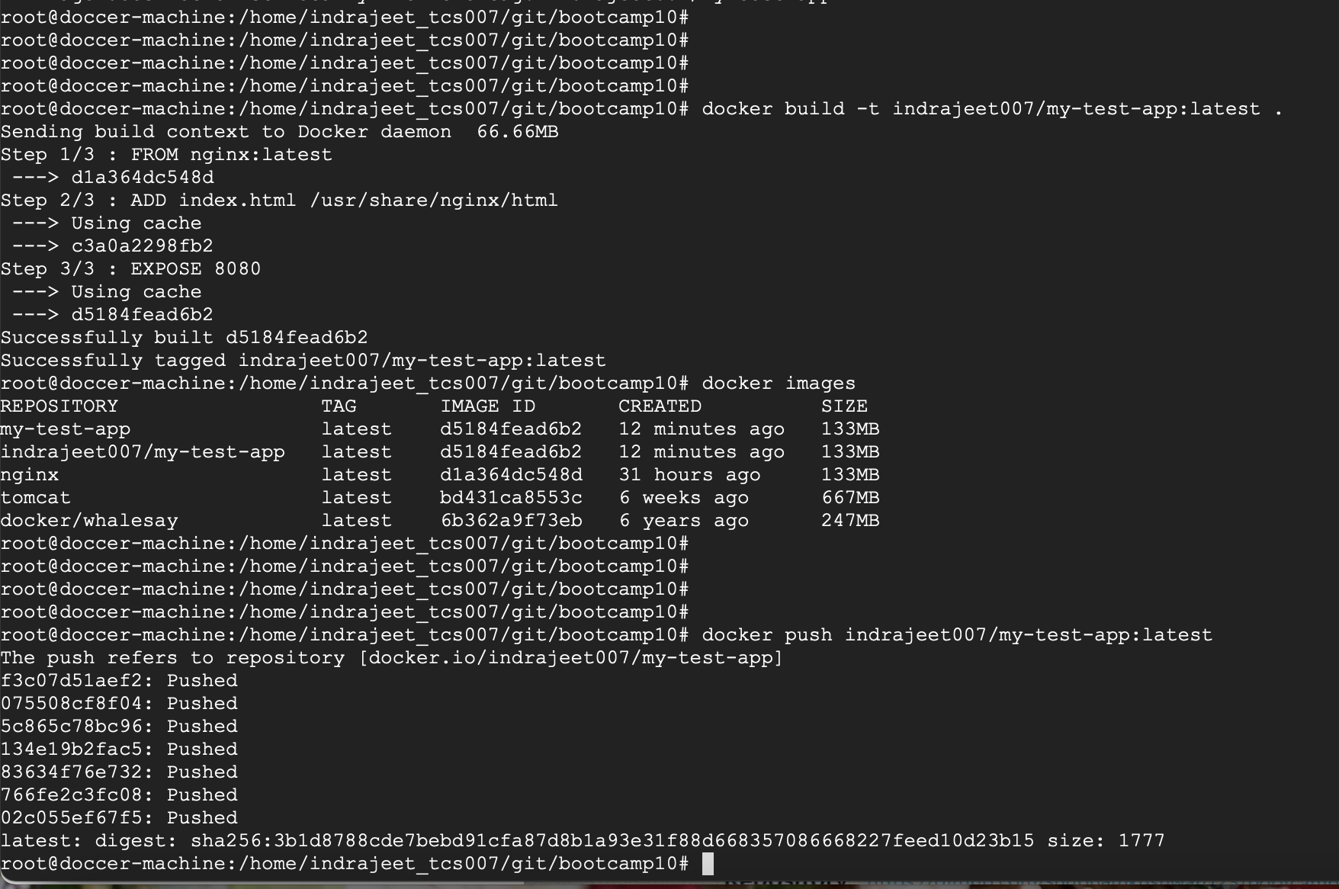
5. docker image can be seen in docker hub and is available for public: 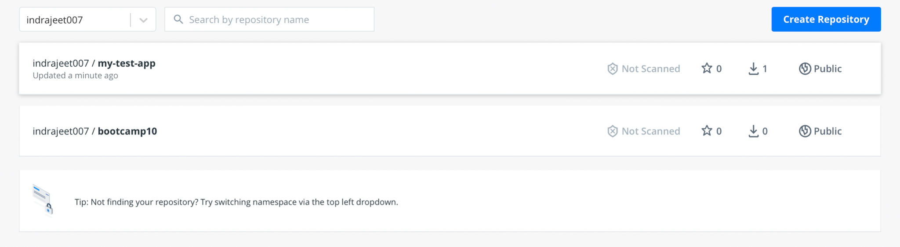
6. deleted the existing image and pulled a new one from the image pushed earlier to docker hub: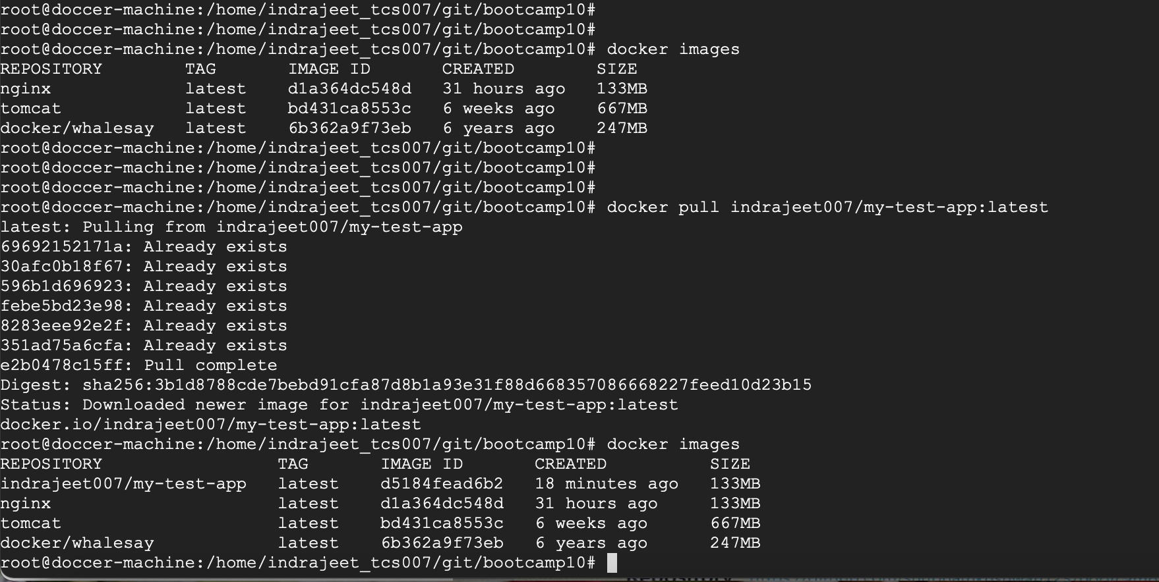
7. ran the image and the output can be seen below:
8. Next created the below compose file to run both the nginx and mysql as docker-compose: 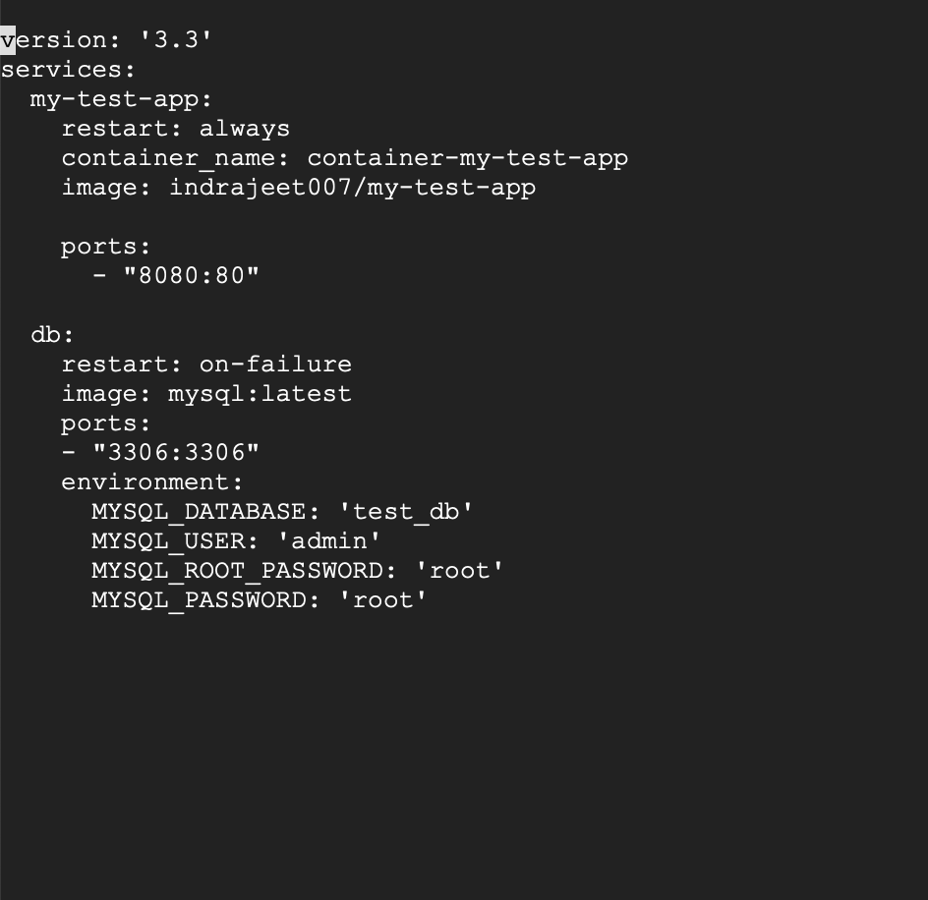
9. executed the docker-compose up command and the containers can be seen below: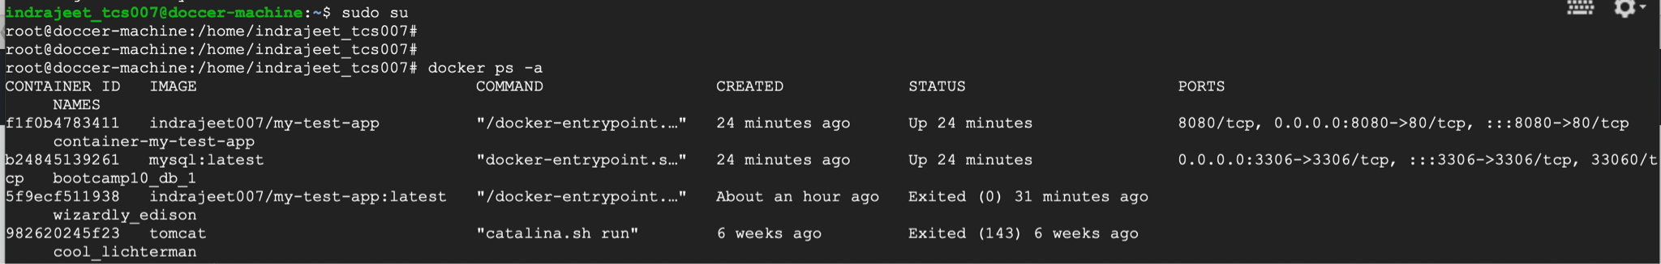
10. connected to the mysql container by running the docker exec command: 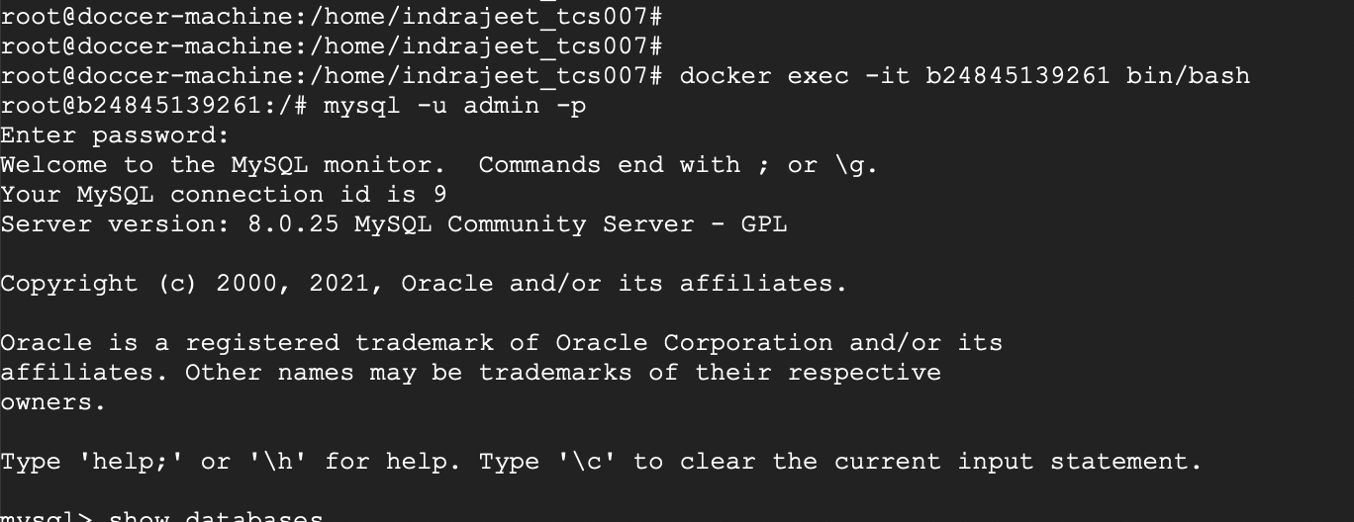
11. created test table and inserted a sample value: